Title Page – VERSION 2 – dated June 15, 2019

Title: Spatio-Temporal Patterns of Disability in India: 2001-2011

Authors:

Ramya Naraharisetti^{1*}, and Marcia Castro²

¹Department of Epidemiology
University of Michigan School of Public Health
1415 Washington Heights
Ann Arbor, MI 48109
Tel: 734-972-5692
rsetti@umich.edu

² Department of Global Health and Population
Harvard School of Public Health
665 Huntington Avenue, Bldg I, Room 1113
Boston, MA 02115
Tel: 617-432-6731
Fax: 617-432-6733
mcastro@hsph.harvard.edu

*Corresponding author

Abstract

Background. The purpose of this study is to examine spatial patterns of disability prevalence in India in and between 2001 and 2011 and utilize these trends to predict district-wise prevalence in 2021.

Methods. Data come from the 2001 and 2011 Indian Census Data of persons with disabilities, categorized by impairment of sight, hearing, locomotor, cognitive and speech. There number of districts in Indian changed from 593 to 640 from 2001 to 2011 respectively. Population density weights were used to compare all districts across time. We use local indicators of spatial autocorrelation (LISA) to identify high-high and low-low statistically significant spatial clusters (SSSA) of disability prevalence by district in 2001 and 2011. We also identify SSSA which have experienced increases or decreases in disability prevalence during this time and predict the prevalence of disability by district in 2021 using demographic projections of the population age distribution by district.

Results. Significant high-high and low-low clustering patterns in disability were found in 2001 and 2011. Certain regions had larger increases in disability prevalence (and subsequent predicted prevalence in 2021) compared to others.

Conclusions. Programming and policy around disability in India could and should be targeted by region. Such targeted efforts to reduce disability could help prioritize limited resources.

Keywords. Disability; India; Spatial Patterns; Clustering Patterns, Local Indicators of Spatial Autocorrelation; Regional Patterns; Disability Planning; Persons with Disabilities; Spatio-Temporal

Introduction
India has the largest population of persons with disability (PWD). The percentage of PWD went from 2.1% (21.9 million) in 2001 to 2.21% (56 million) in 2011 [11]. Yet, little research has been done to assess the spatial and temporal patterns of PWD in the country. Previous studies have alluded to the existence of differences in disability experience across states. Based on the period of 1991-2001 Census data, a Disability Index was calculated for 26 states in India [10]. The index was constructed to measure the disability health status (based on weights given to the various types of disability) of different states of India. While descriptive, the index showed variability across states, and between urban and rural areas. To the best of our knowledge, no attempt has been made to assess the spatial pattern of disability in India, considering different types of disability, at a finer scale. Further, this is the first time that there have been two Census surveys in India which captured information on disability over time, allowing a disability prevalence to be understood across time and space at the district level.

There are two main reasons why disability maybe spatially distributed across a country or region. The first had to do with environmental exposures and the second has to do with migration patterns. Environmental exposures such as pollution, toxic exposures, low quality healthcare and nutrition may lead to disability and vary across space [7]. Further, once a person has a disability, environmental (e.g.,pollution in urban areas), structural (e.g., availability of specialized health care), economic (e.g., income), and social (e.g., presence of family members) factors can impact the decision of where to live [9] [10]. Recently, these issues are gaining more attention as research on the spatial patterns of disability increases [5] [6] [4] [12]. This is an important advancement in knowledge, since the distribution of overall disability and specific disability categories among PWD may be very location specific, with important implications for effective planning and targeting of services.

This paper addresses this gap in the literature, and aims at understanding if there are any significant spatial and/or temporal pattern of PWD in India in and between 2001 and 2011. Five different types are considered: hearing, visual, speech, cognitive, or locomotor disability. Our hypothesis is that significant clusters of disability prevalence in 2001 and 2001 and change in disability prevalence between 2001 and 2011 could happen because of: (a) differences and changes in environmental exposure across space, which may lead to adverse health outcomes resulting in disability; and/or (b) differences and changes in social, economic and environmental factors across space that determine where an individual with disability lives.

METHODS

Data

We used the 2001 and 2011 Population Census, which for the first time in 2001 included multiple questions on disability. According to their methodology section, each person was asked if he/she suffered from a physical or mental disability according to five categories, as detailed in Table 1: speech, sight, hearing, mental (cognitive), or movement (physical) (Commissioner 2001). If a person suffered from two or more types of disabilities only one was recorded, and it was left to the respondent to decide which one they wanted to be classified into. Persons with temporary cognitive or locomotor inability (due to acute medical conditions) on the date of enumeration were not considered as disabled. In the 2011 Census there were some changes to the classification of disability, mainly two measures of mental (cognitive disability) were asked: mental retardation and mental illness and an additional question was added to classify people with multiple disabilities.

The disability data were detailed by district, which is the first level administrative unit within an Indian state; there were 640 districts in 2011 and 593 districts within the 28 states and seven union territories of India (Figure 1). These data were spatially joined with a boundary map of Indian administrative units (retrieved from Harvard GeoSpatial Library, Cambridge, Massachusetts). The data were projected using Kalianpur 1975 India Zone IIb. Data joining, projection and mapping were done in ArcGIS 10 (Environmental System Research Institute, Redlands, California). There were changes to districts between the 2001 and 2011 Census, suggesting a need for population density weighting. Seven districts in particular were created in 2011 which deviated from the boundaries present in 2001 (namely they were not carved out of just one district but two or three). There were 47 districts in total that were added between the 2001 and the 2011 Census. These are illustrated are highlighted districts in Figure 2.

The development of the merged data set required many decisions with regard to weighting. For those districts that were not carved out into more than district, we weighted the population based on the square kilometers (sq km) of the district. We start with those districts that were carved from. We multiplied the 2001 population with the sq km of the 2011 new district divided by the sq km of the 2001 district. In most cases, this weighting resulted in a perfect match (where the sq km from the 2001 district equaled the sum of the newly created district and the 2011 district sq km area). There were although some discrepancies such as for the newly created district Ganderbad from Srinagar and Shupiyan from Pulwama. In those cases, we utilized the values of the square footage reported and attributed these to reporting error. If a district was carved out of more than one district then we used the 2001 population of both districts summed together and then weighted this by the fraction of the sq km of the new 2011 district and the sum of the sq km of the 2001 districts from which it was carved. If two districts were carved of the same district (and that district had another district from which it was carved out of) then we utilized the overlap in the map to determine the square km contributed from each old district. If one district was carved out from three districts (and those districts were not used to make any other districts) then the difference in the values between original district population and the weighted district population were taken. There were other cases when the sq km of the 2011 district was larger than the sq km of the 2001 district. In the example of Jehanabad in Bihar. Since the difference was 931 and the value was 3968 we assumed that this was a typo and removed the 9. It seems that some states have more accurate sq km data than others. For example, Arunachal Pradesh matched up completely. If there were two districts which were carved out of one district only, then we multiplied the difference in the 2001 population and the weighted population and multiplied by the fraction of the sq km of the new village and the difference between the sq km of the district from which it was carved out from (2001 and 2011). One districts the sq km value was larger in 2011 and there were not an immediate fix possible such as for Kokrajhar in Assam. In this case we assumed that the district sq km did grow and weighted accordingly. There were two new districts in Assam for which it would not possible to calculate the weight, Baksa and Chirang because they were carved out of the same district (and other districts also were carved from to create these districts). Therefore, there were two unknowns in the problem and we could not solve for how many people would have been in this sq km of the district. In this case we utilized a density weight where we summed all the people from the districts from which the new district was carved divided by the sq km of the original districts from which it was carved and obtained person per sq km for each variable which was then multiplied by the sq km of the new district.
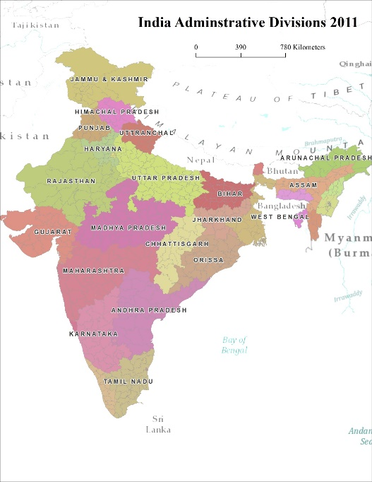

Figure 1. Districts Added between 2001 and 2011 Figure 2. Map of Indian Districts and States
between 2001 and 2011

Variables of interest were all summarized at the district-level for 2001 and 2011: (i) proportion of PWD in the population; (ii) proportion of PWD with speech impairment; (iii) proportion of PWD with seeing impairment; (iv) proportion of PWD with hearing impairment (vii) proportion of PWD with cognitive impairment (collapsed values for mental illness and retardation in 2011 Census) and (viii) proportion PWD with physical impairment. For the purpose of this paper we did not include the category of multiple disabilities because it was not recorded in the 2001 Census survey as a separate category. We did although include the number of people with multiple disabilities in the total measure of disability prevalence (i).

In addition to individual years of disability prevalence we were interested in the changes in prevalence over time between 2001 and 2011. We generated a summary measure of change in prevalence comparing the proportion of PWD in the population (at the district level) (prevalence in 2011 subtracted by the prevalence in 2001).

Lastly, we were also interested in using the demographic projects of the population age distribution by district to predict the disability prevalence by district in 2021 (the next Indian Census).

Spatial Analysis

District-wise spatial variation of (a) PWD generally and of disability type-specific PWD were assessed in 2001 and 2011 and (b) changes in disability prevalence between 2001 and 2001 through the use of the local Moran’s I indicator of spatial association (LISA) 9999 permutations [1]. Significant clusters were identified using a k-nearest neighbors contiguity neighborhood definition, with k=4 and row standardization. All islands were removed from the analysis because they cannot be assessed using LISA given they do not have any neighbors. Results were corrected for multiple testing utilizing the false discovery rate (FDR) control procedure (Castro and Singer 2005). Mapping, spatial analysis and FDR correction was done in ArcGIS Pro (Environmental System Research Institute, Redlands, California) and data analysis was conducted in SAS [2] [3].

RESULTS

Descriptive Statistics
The average number of PWD per district was 36,943 in 2001 and 41,898 in 2011. In 2001, the highest mean proportion at the district level was sight (47.5%), followed by movement (27.6%) and then cognitive (10.1%). Hearing and speech account for about 7-8% of PWD each. The greatest variability across districts was in the sight category, followed by movement. Twenty-seven percent of PWD resided in urban areas (with some districts not having any PWD residing in urban areas and others having all PWD in urbanized areas).

Spatial Clustering Results

The results of our main spatial analysis, looking at clusters which experienced great increases or decreases in disability prevalence in the ten years between the two Census surveys was interesting. First, we found that after FDR correction mostly low-low clusters (significant decreases in prevalence of total disability surrounded by other similar districts) were identified. This was in the southwest and far east of India. One high cluster of cognitive disabilities were identified in the northern most part of India, where much conflict has occurred in the past. Some high clusters of movement disability were identified again in the far north and also in the southeast of India. A few high-high and a few low-low clusters of sight disability were significant in the north and the south. Lastly, on large high-high cluster of speech disability was identified in the southwest of India. Finally, when considering the prevalence of disability across the two years and projecting into 2021, we found the following. The average prevalence of disability by district in 2021 = 2.195% (-0.054, 7.65) from 2.152% (0.076, 4.51)in 2011 and 2.109% (0.085, 4.69) in 2001. This was calculated using the percent difference in disability prevalence between 2001 and 2011 by district and using the actual prevalence of disability in 2011 by district to get a district wise 2021 projection.
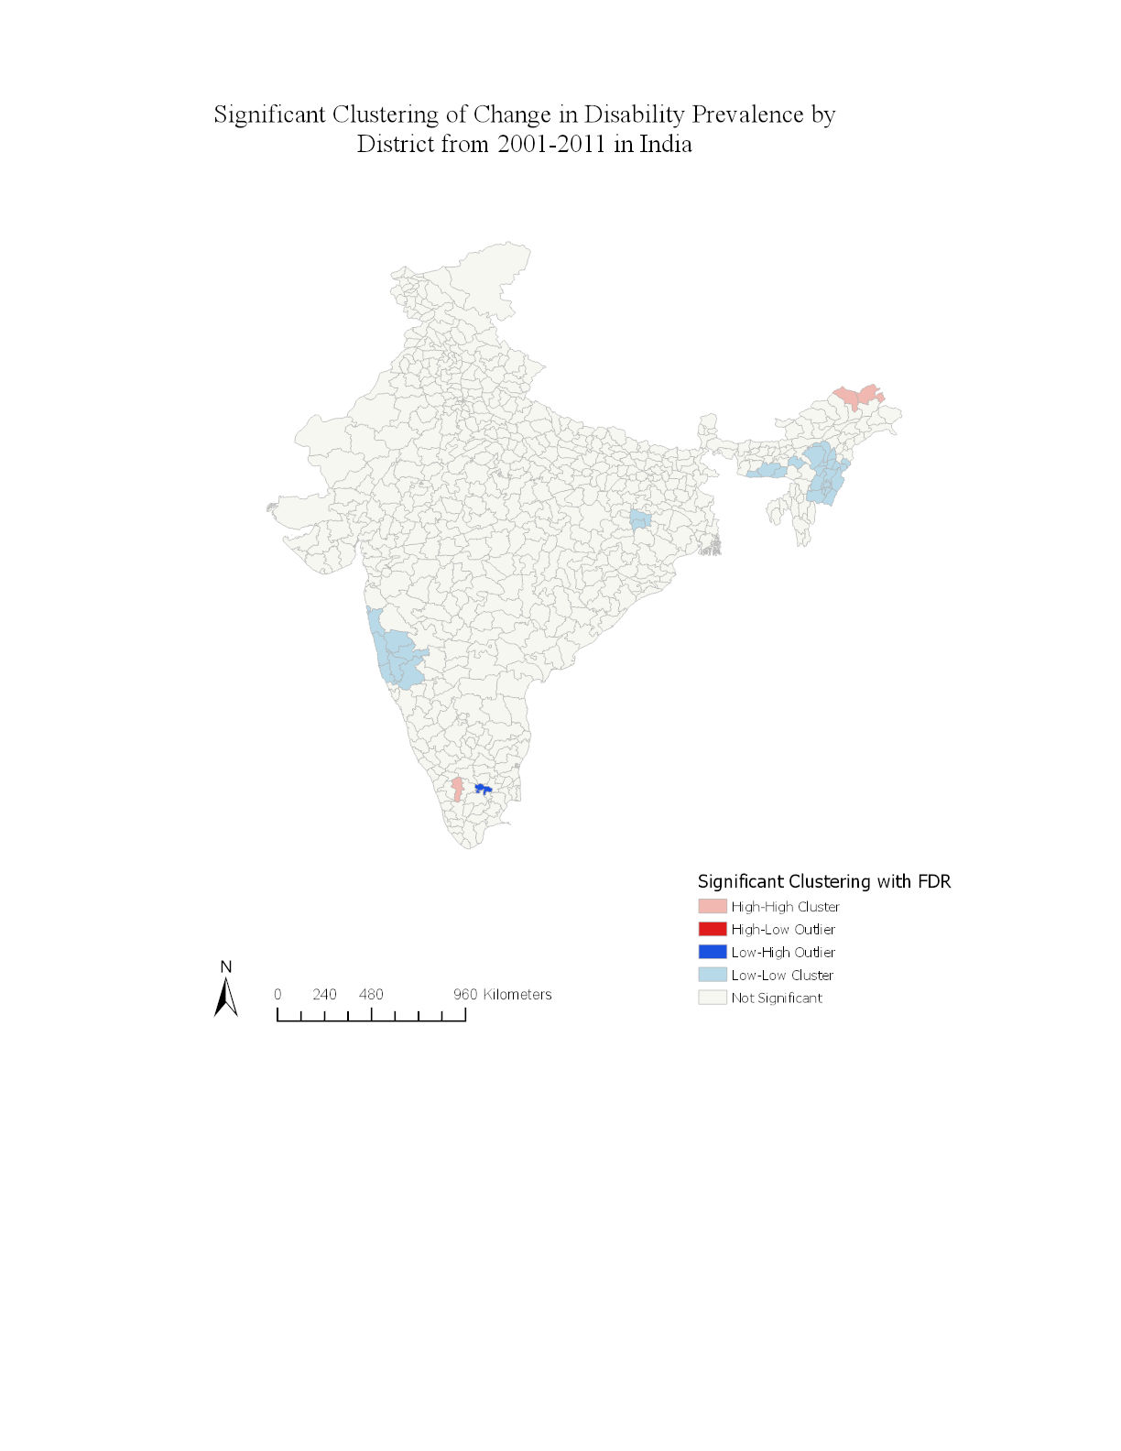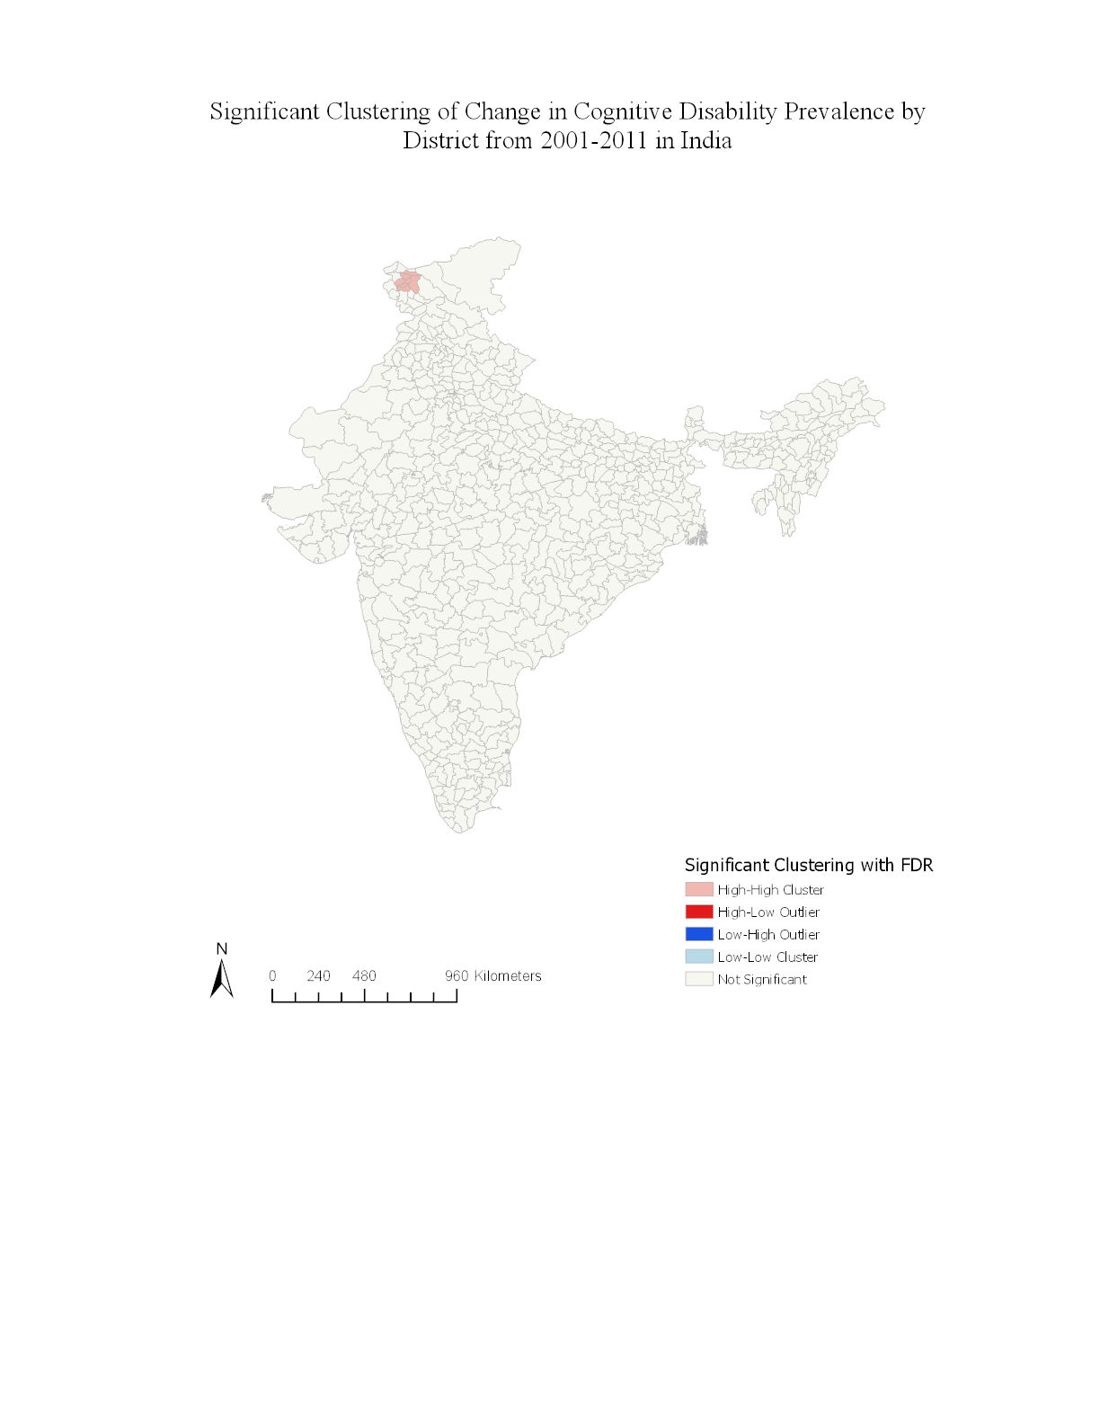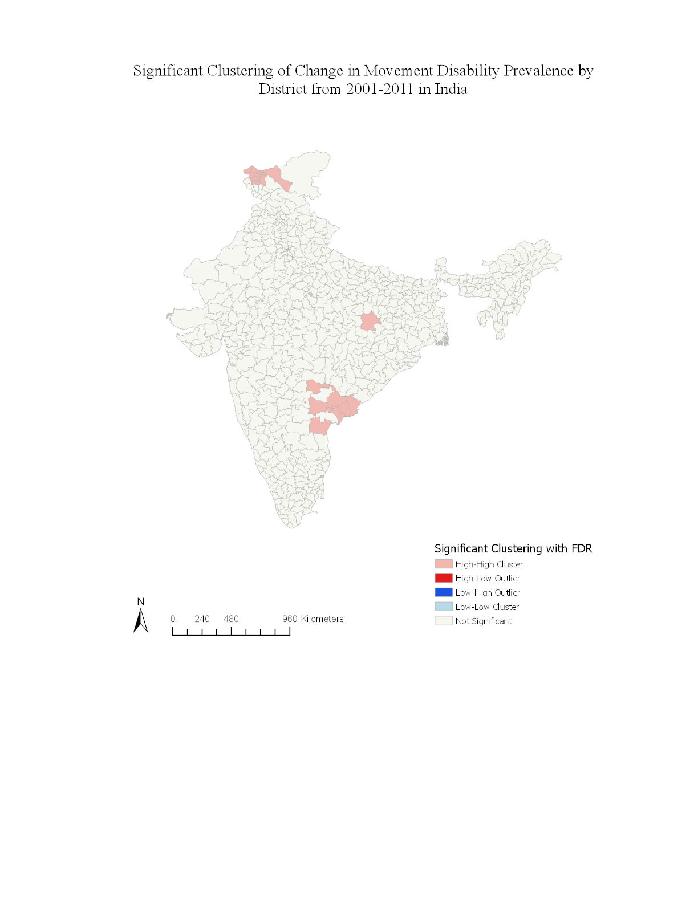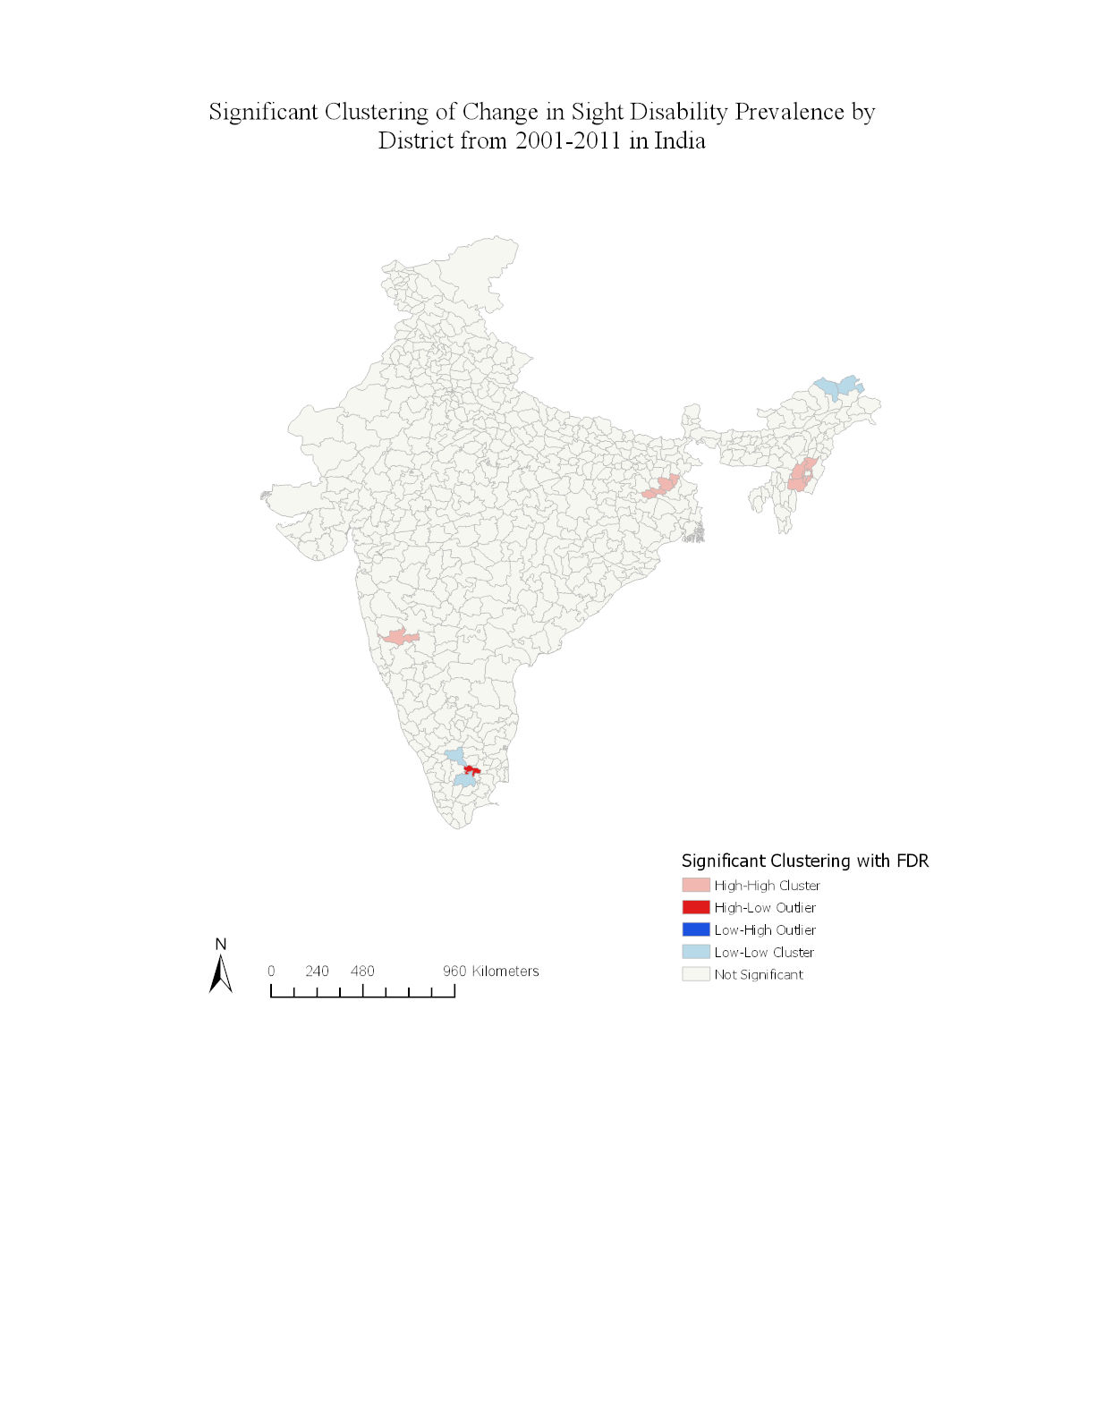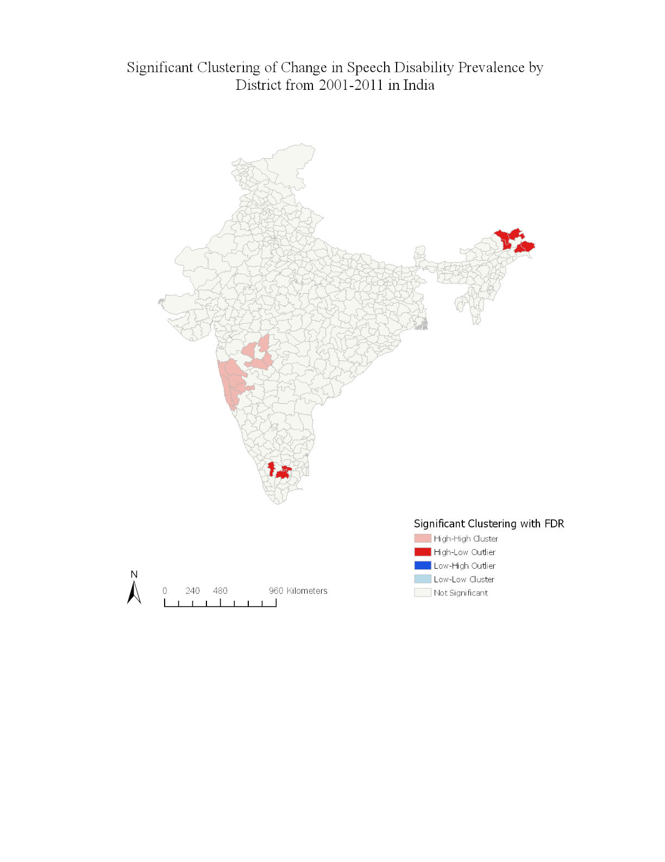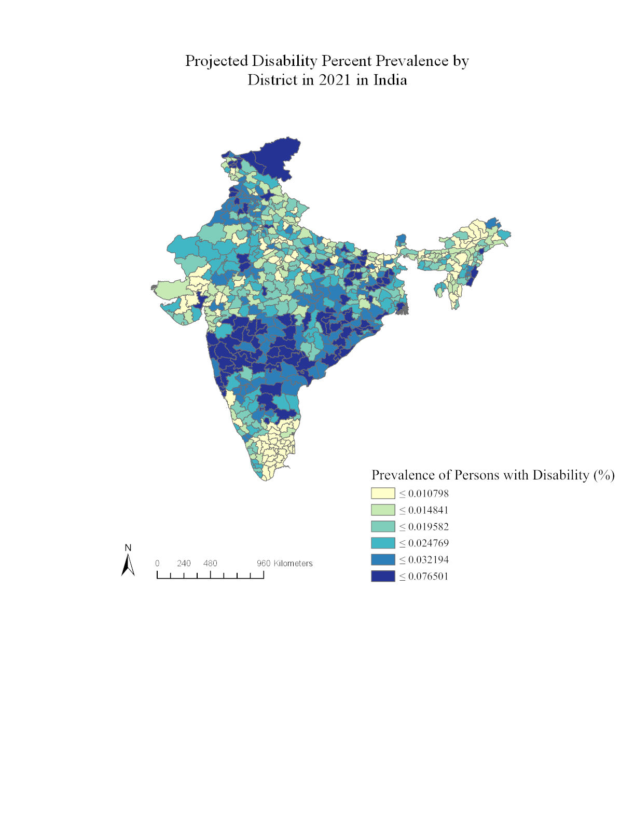

DISCUSSION

This exploratory view of the data, given inconsistencies with Census data and reporting, only suggests hypotheses to test for further analyses. Nonetheless, the principle message is that, all the maps of disability type taken together, confirm that disability type is a highly clustered regional phenomena. A combination of social and environmental processes operating in space over time have somehow conspired to partition the country into regions with higher concentrations of certain disability types than others with a few ‘island’ districts of high/low and low/high disability type.

Recent debates about the varied estimates of disability are relevant to the implications of this study. A recent article on disability estimates from the 2001 Census and the 2002 58th round of the National Sample Survey (NSS) concludes that “prevalence estimates in the census and the NSS are clearly not comparable… and it is unsure what aspects of disability are captured by the census and NSS current disability definitions” [8]. Therefore caution should be exercised in using either the census or the NSS for policy purposes [7]. Nonetheless, the Indian Census is a powerful data set due to its representativeness in the capture of key variables such as literacy, sex and disability type for the entire population. Furthermore, future work can utilize this methodology when future rounds of the Census are made available.

References

[1] L Anselin. Local indicators of spatial autocorrelation—lisa. Geographical Analysis, 27, 1993.
[2] Luc Anselin, Ibnu Syabri, and Youngihn Kho. Geoda: an introduction to spatial data analysis. Geographical analysis, 38(1):5–22, 2006.
[3] Marcia Caldes de Castro and Burton H. Singer. Controlling the false discrovery rate: A new application to account for multiple and dependent tests in local statistics of spatial assosciation. Geographical Analysis, 38:180–208, 2005.
[4] Valorie A Crooks, Michael L Dorn, and Robert D Wilton. Emerging scholarship in the geographies of disability. Health & place, 14:883–888, December 2008.
[5] Brendan Gleeson. A geography for disabled people? Transactions of the Institute of British Geographers, New Series, 21(2):387–396, 1996.
[6] Rob Imrie and Claire Edwards. The geographies of disability: Reflections on the development of a sub-discipline. Geography Compass, 1(3):623–640, 2007.
[7] Robert Jefferey and Nidhi Singhal. Measuring disability in india. Economic and Political Weekly, pages 22–24, 2006.
[8] Sophie Mitra and Usha Sambamorrthi. Disability estimates in india: What the census and nss tell us. Economic and Political Weekly, 41(38):23–29, 2006.
[9] Krishna Mohan and Sandeep Thind. Bio-Social Issues in Health, chapter Disabled Population in India: A Geographic Study. New Dehli Northern Book Centr, 2008.
[10] Dilip Nath and Mousumi Nath. Measuring disability in india: Spatial and socio-economic variations. Los Angeles, California, 2006. Population Assosciation of America.
[11] Office of Registrar General Commissioner. Census 2001 and 2011. http://censusindia.gov.in/, June 2019.
[12] Nancy Worth. The significance of the personal within disability geography. Area, 40(3):306–314, 2008.

